Logistic Regression Analysis of Hotel Reservations
Ashley Horner
Student ID: 0117741877
Western Governor’s University
D214 Capstone – Task 2

A – Research Question
Hotels across the world have a fundamental business need to ensure that they book as many of their rooms as possible so that they are profitable ventures. However, even reserving every room in a hotel would not suffice to meet this requirement considering that in Europe “in 2018 49.8% of bookings reserved on the OTA Booking.com were cancelled” (Banza, 2020).
Banza found during his 2020 CatBoost analysis (a gradient-boosted decision tree) that the larger the lead time on the hotel reservation, the higher the likelihood that the reservation would be cancelled. If approximately half of reservations are canceled, the hotel may want to employ a business strategy of intentionally overbooking to help manage the impact of a high cancellation rate. This could lead to higher occupancy rates and therefore greater business viability for the hotelier.
Logistic Regression assesses the probability of a binary outcome based on two or more independent variables. Logistic Regression is a statistically valid strategy for the business problem at hand since the desire is to predict a binary outcome: either the reservation will be cancelled, or it will not be cancelled. The data set for the study also includes two of the factors found in other studies to contribute to cancellation predictability: lead time and that the reservation was booked online (IBM, n.d.). The research question for this study is whether Logistic Regression can be employed on the subject dataset to predict hotel reservation cancellations with at least 60% accuracy.
The hypothesis of the study is that a Logistic Regression model can be employed with over 60% accuracy.

B – Data Collection
The data used for the study is “Hotel Revenue,” publicly available from Kaggle.com (Krishnadas, 2022). This dataset contains 141,950 records with global hotel reservations booked via various channels spanning from 2018 through 2020. A list of the columns from this dataset is below.

Variable | Type
Hotel | Categorical
lead_time | Continuous
arrival_date_year | Categorical
arrival_date_month | Categorical
arrival_date_week_number | Categorical
arrival_date_day_of_month | Categorical
stays_in_weekend_nights | Categorical
stays_in_week_nights | Categorical
Adults | Continuous
Children | Continuous
Babies | Continuous
Meal | Categorical
Country | Categorical
market_segment | Categorical
distribution_channel | Categorical
is_repeated_guest | Categorical (binary)
previous_cancellations | Continuous
previous_bookings_not_canceled | Continuous
reserved_room_type | Categorical
assigned_room_type | Categorical
booking_changes | Continuous
deposit_type | Categorical
days_in_waiting_list | Categorical
customer_type | Categorical
Adr | Continuous
required_car_parking_spaces | Categorical
total_of_special_requests | Continuous
reservation_status_date | Categorical

The data is presented as an Excel spreadsheet, with each year on a separate sheet within the workbook. That the data is already presented in structured, tabular form allows for an increased usability and eliminates any need to parse or impose structure to facilitate analysis, an advantage that helped the efficiency of the study. Rather than attempt to code the data ingestion to handle that the data was split across multiple sheets, that disadvantage was overcome by simply combining the data within Excel and then saving the combined result as a single dataset in a .csv file.

C – Data Extraction and Preparation
This study is completed using Python 3.11 in a Jupyter Notebook (via Anaconda). As opposed to the “non-standardized code [which] makes R look clunky and awkward,” “Python is the go-to language in the production sector because its simple syntax allows programmers to perform complex operations using fewer lines of code” (BasuMallick, 2022). BasuMallik also states that Python is “ranked as one of the most in-demand tech skills by employers, making it an in-demand skill” as opposed to the lower demand for R in non-academic settings. Since the focus of the study is on a business rather than academic question, the more business-oriented tool has been selected for the project – Python. Python also excels at integration into web-based applications: considering that many hotel reservations are made via technology like online travel booking websites, the ability to integrate forecasting with other online datasets or toolsets is an asset to the overall business need. Python’s flexibility and therefore option to integrate with other programs or toolsets would provide the business with more downstream options than the stricter limitations of SAS (GeeksForGeeks, 2023). A disadvantage of Python is that R would have had greater statistical power and visualization capability since R is a tool designed for visualizing statistics, however that disadvantage was not compelling enough to merit a change in toolset.
To begin the python project, the combined results from a .csv file were read in and initial packages imported.
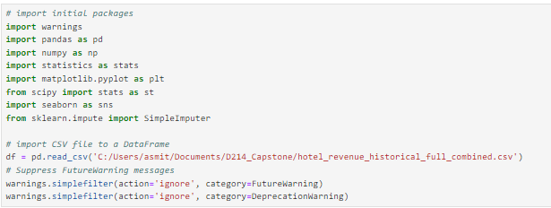
This allows for the data to be explored and data cleaning applied. For the purposes of this study, only the data from Great Britain will be analyzed. This eliminates bias in the outcome that might potentially be related to regional differences. The dataset is therefore filtered by the value in the “country” column and an updated record count obtained to verify accuracy against the source file. An index is then applied to the dataframe. The result is confirmed accurate in the results from the code block, with only the country code “GBR” returning, alongside a correct record count for this reduced dataset of 13,487 rows.
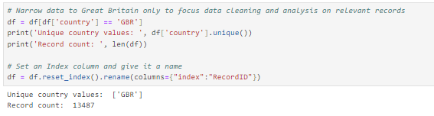
The data is then checked for missing values, as these can negatively impact a Logistic Regression model. The results indicate that the “company” and “agent” columns contain missing values.
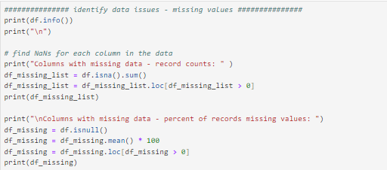
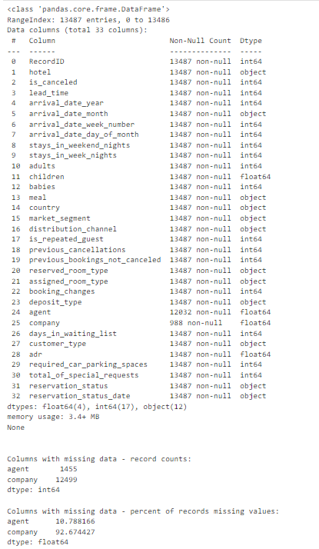
Since neither “company” nor “agent” can be reasonably imputed and missing values cannot be left in place, both columns are excluded from the dataset going forward. The data is checked again for missing values and confirmed to have none following this deletion. At this point, data sparsity is less than 1%.
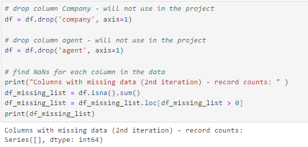

Next the data is evaluated for outliers. To assess outliers, z-scores are calculated. Any z-score less than negative three (-3) or greater than three (3) is flagged as an outlier. The results indicate that there are outliers in several fields. Since some outliers are informative and could be important to prediction, it is possible not all need to be removed. However, extreme outliers should be carefully inspected. The results from this code block will give what the outlier ranges are for each field so that thought can be given to treatment.
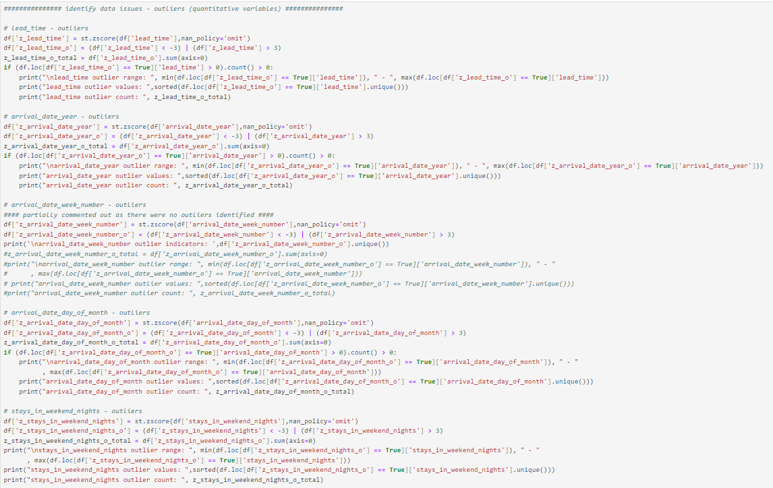
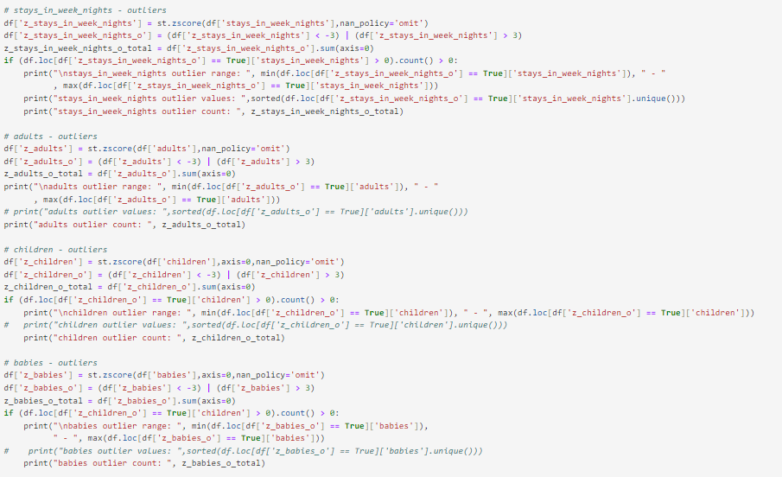
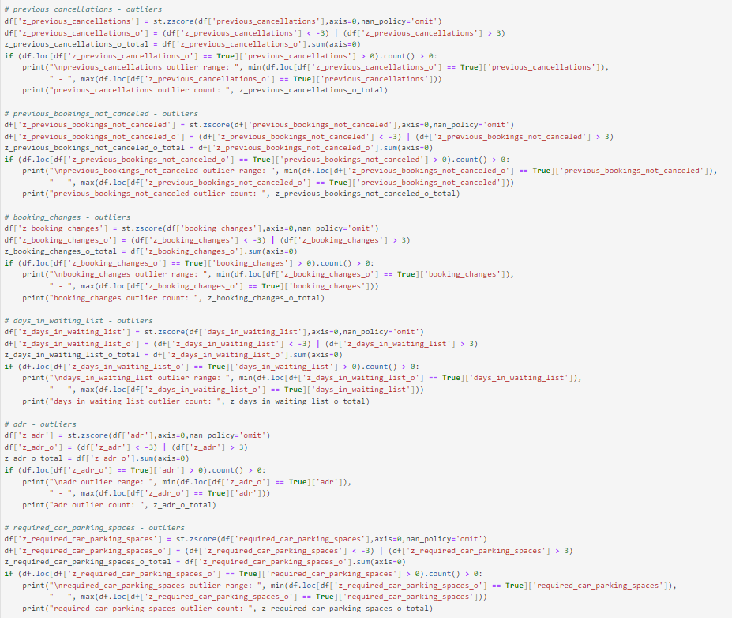
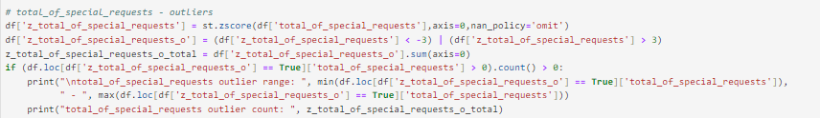
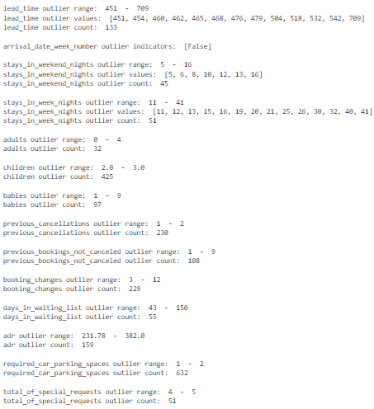
To further evaluate outliers, the results of the above calculations are visualized. This has an advantage of making more extreme outliers easier to identify when visualized against the other data, though the disadvantage of relying too heavily on the visualization is that it can be less precise.
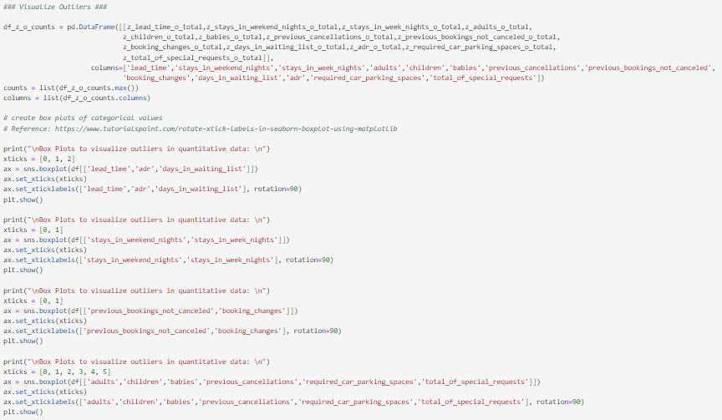
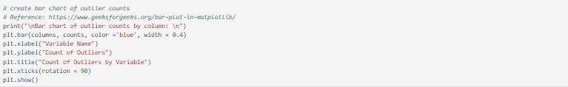
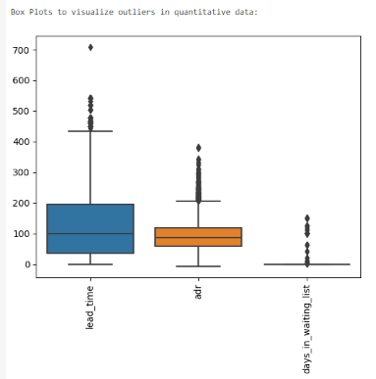
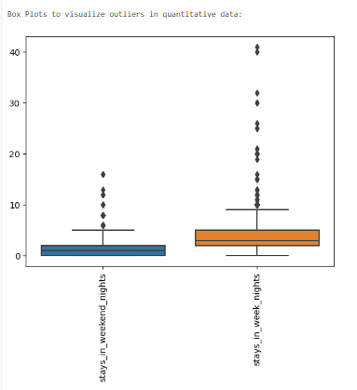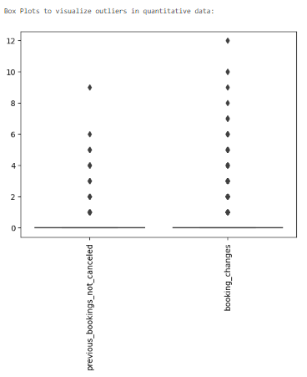
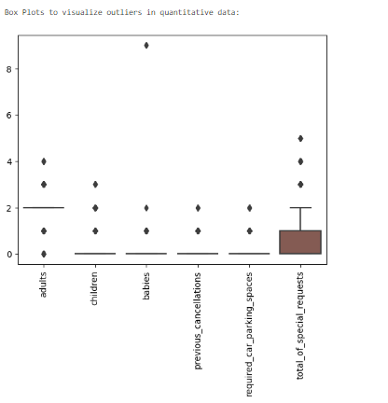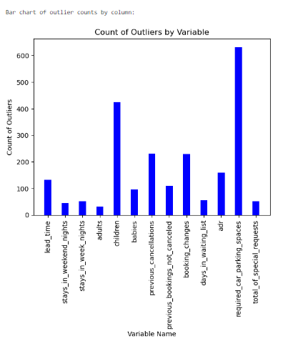
Based on the above results, outliers are treated by first converting the values to null and then imputing to the median. Only outliers that appear more extreme are treated. The others are left in place because their impact on the predictions from the model may be meaningful. This was a decision made as the model was refined and additional iterations performed, with the first iteration including the imputation of all outlier values rather than only those that are more extreme. The updated values are printed for verification and inspection.
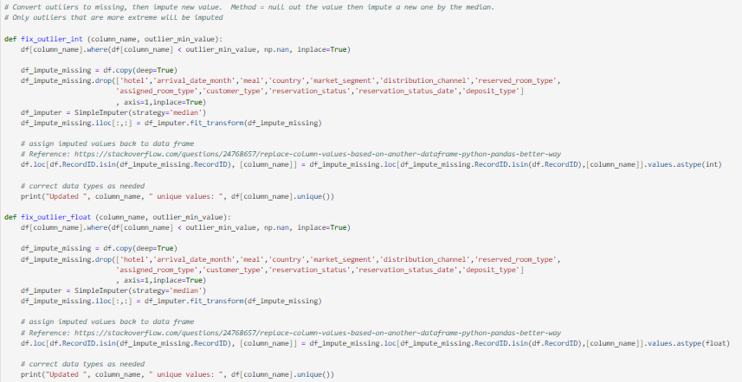
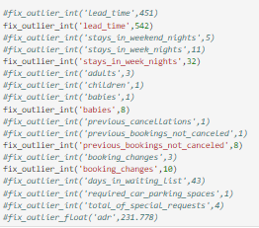
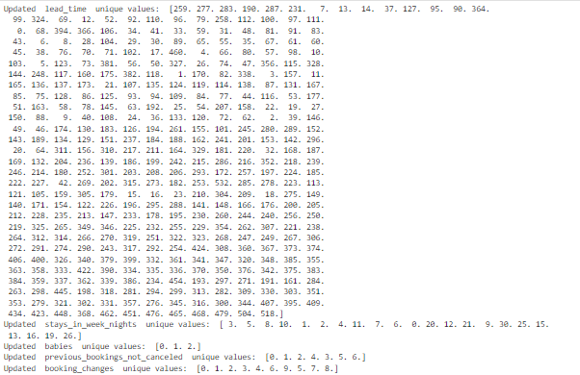
A check for duplication was not performed, as there were no primary keys or other identifiers on the data that could have accurately indicated problematic duplication.
Checks for normal distribution and homoscedasticity were not performed, as these qualities are not requirements for a successful Logistic Regression model (Bobbitt, 2020).
Next, univariate visualizations of the variables and basic summary statistics are created based on variable type. Counts and percentage distributions are calculated for qualitative variables. Mean, median, min, max, and standard deviation are calculated for quantitative variables. Visualization facilitates the identification of visual patterns or lack thereof.
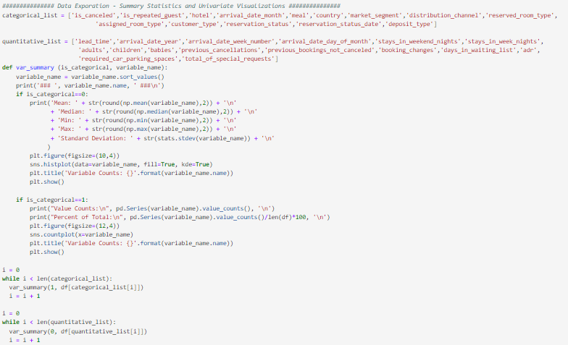
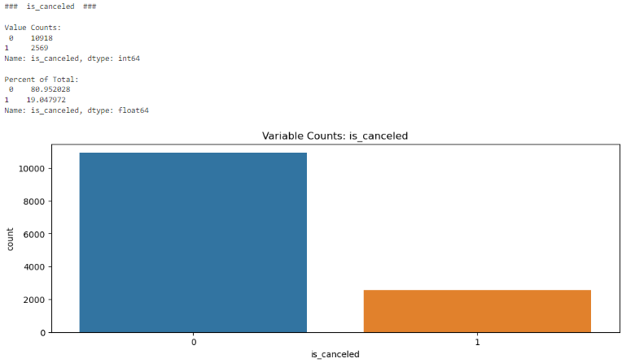
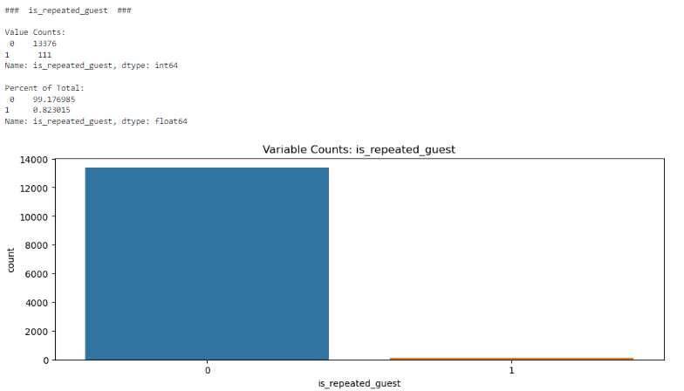
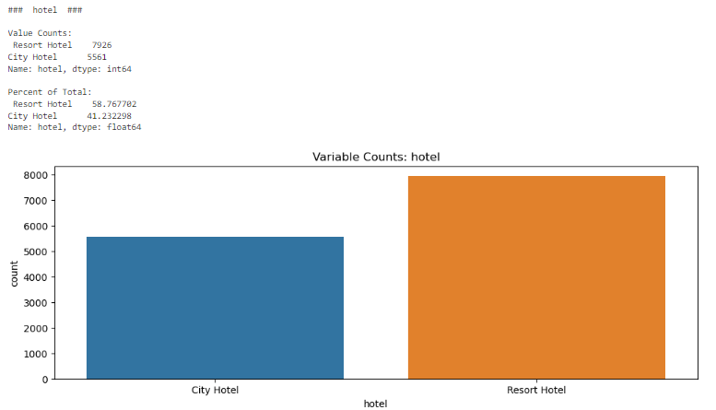
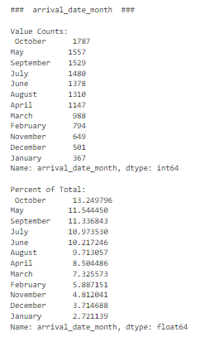
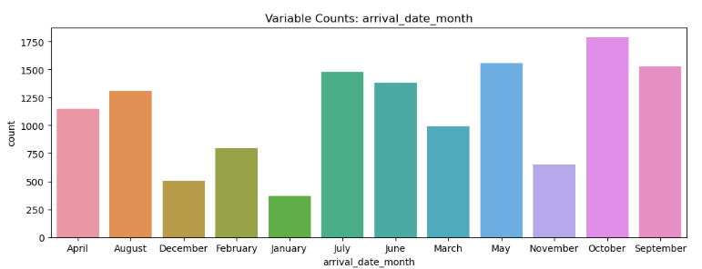
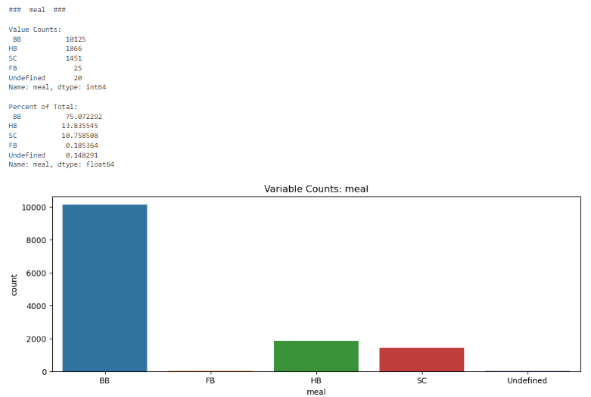
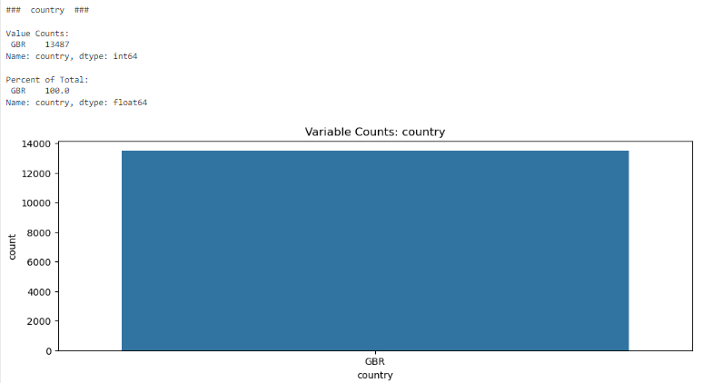
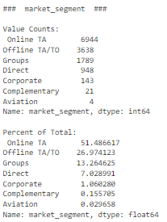
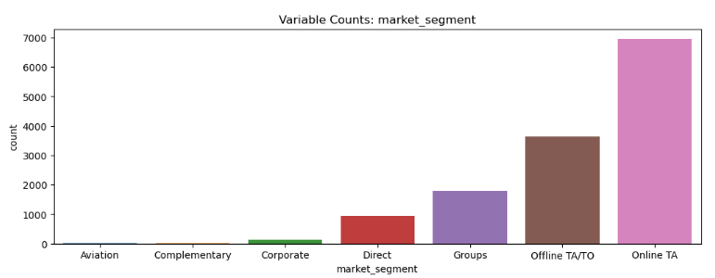

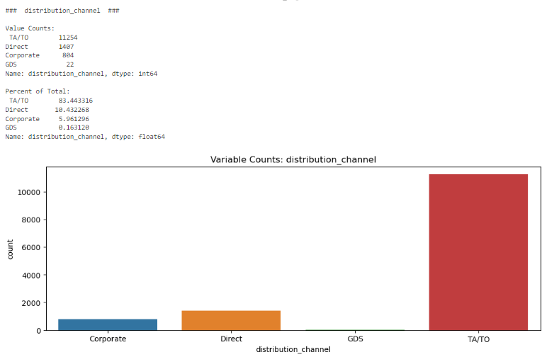
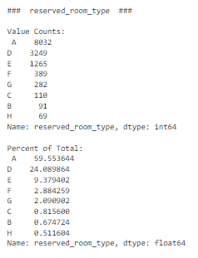
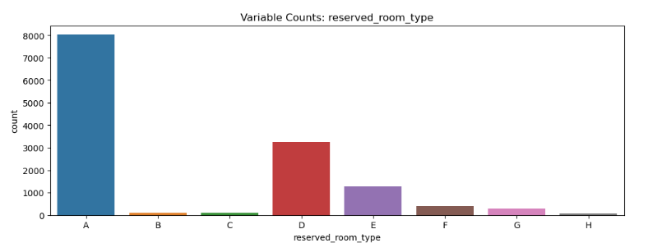
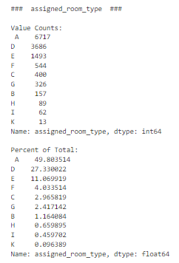
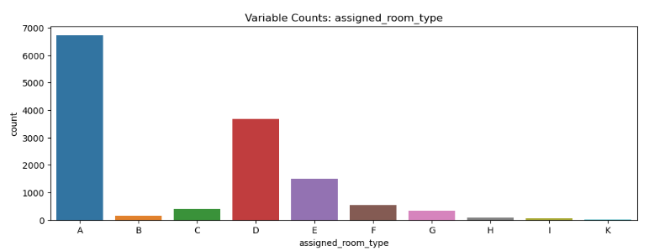
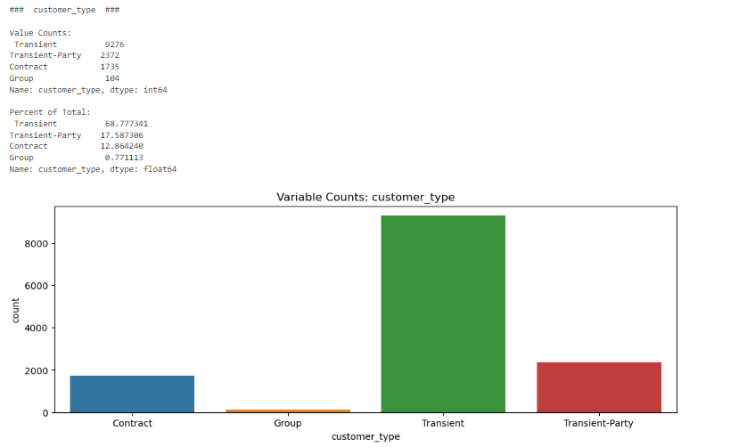
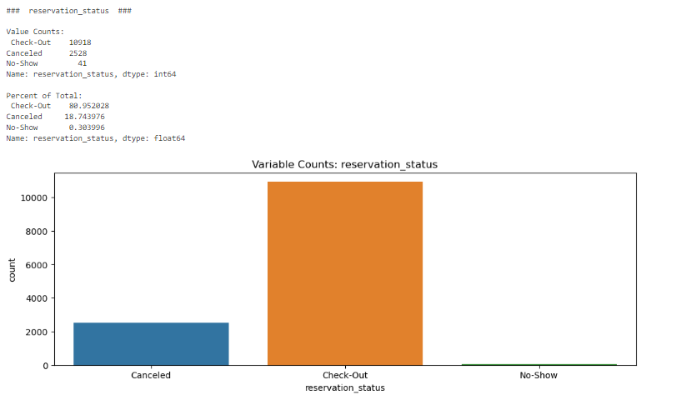
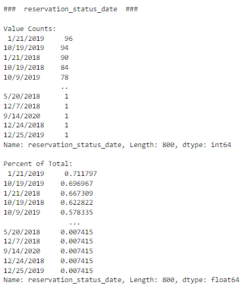
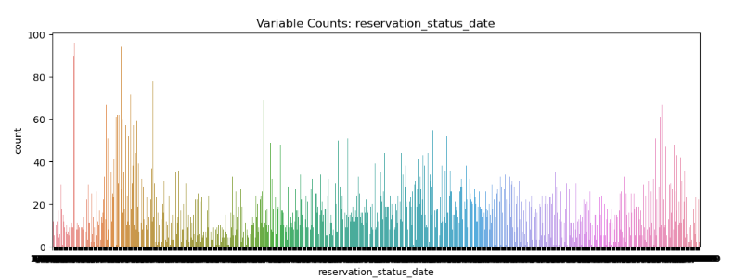
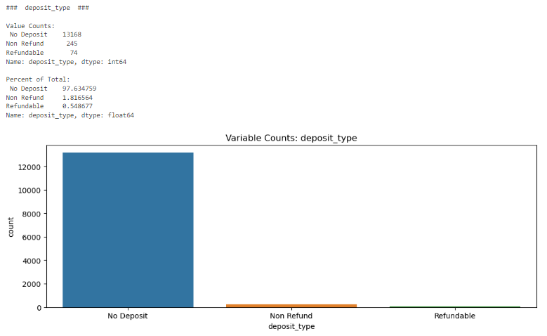
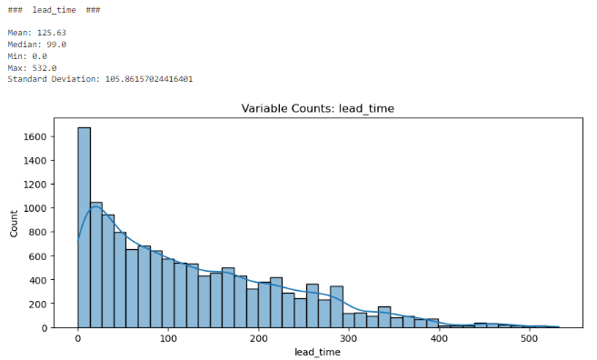
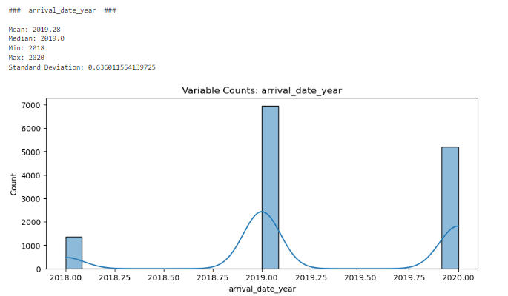
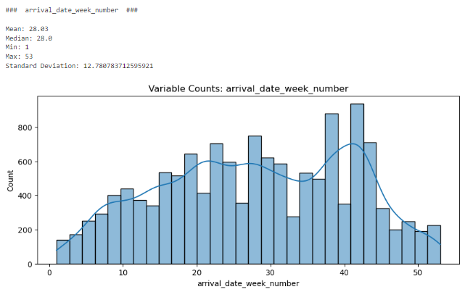
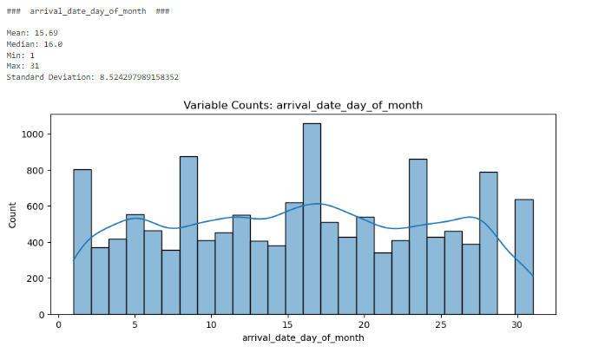
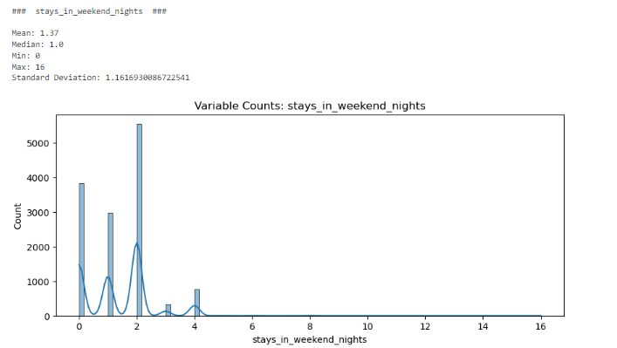
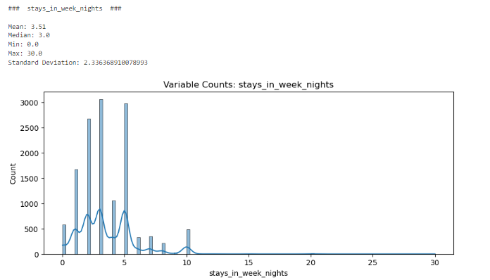
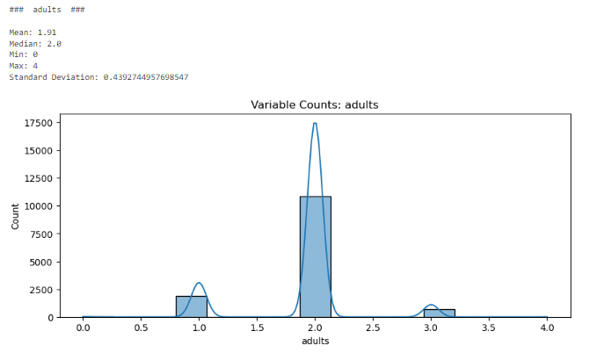
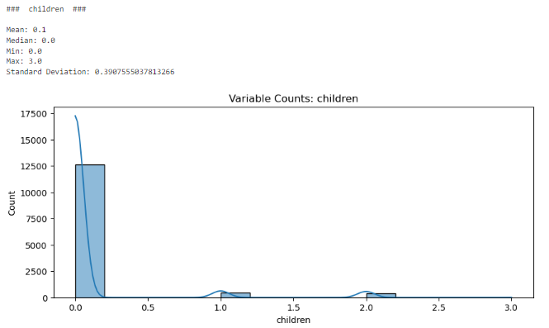
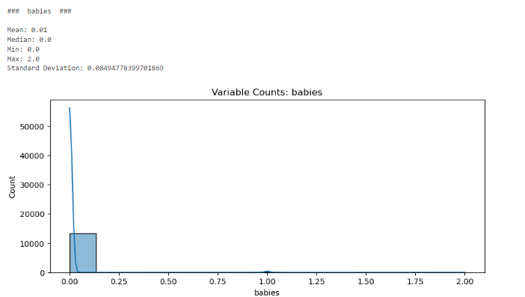
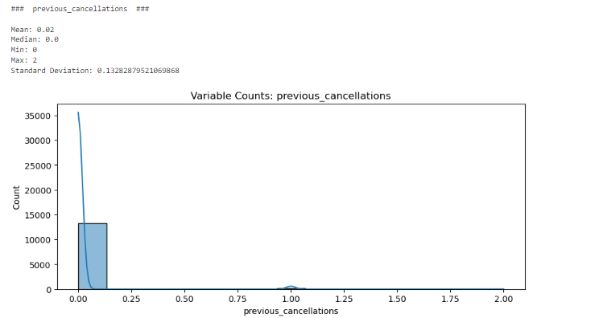
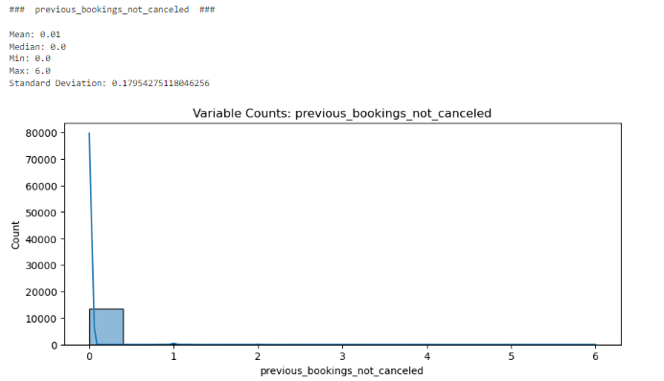
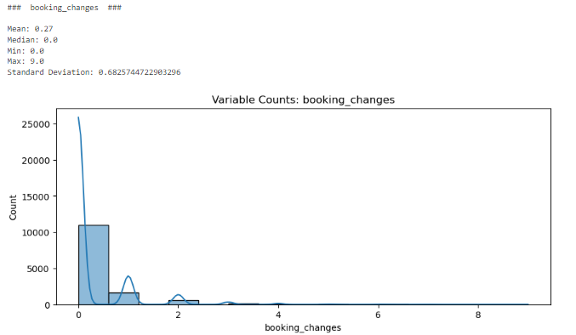
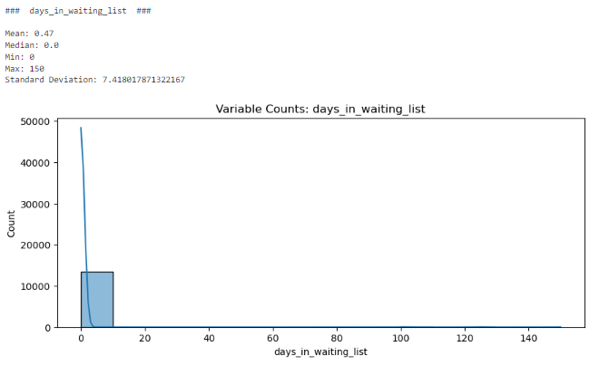
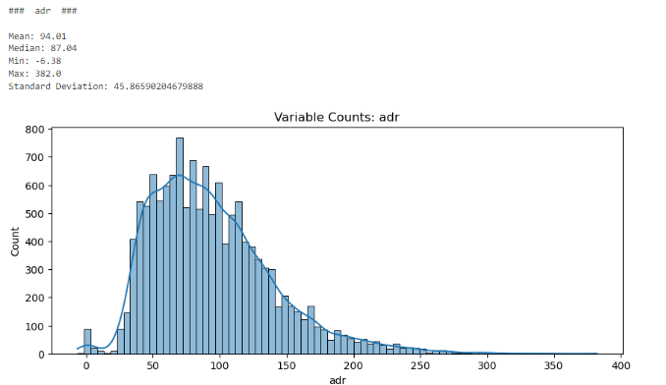
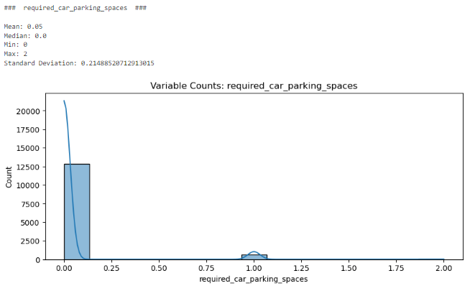
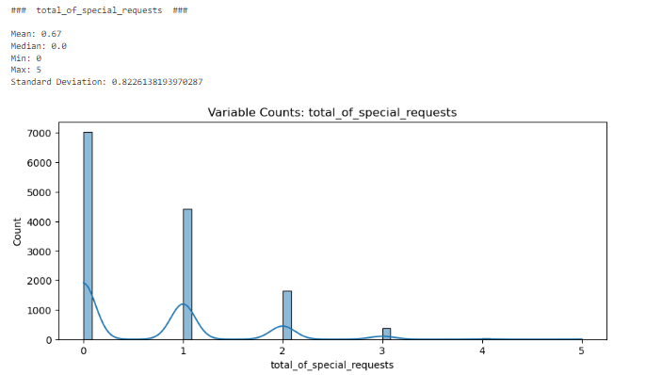
These visualizations serve as a reminder that the “country” column is no longer needed, as all values in the column are now the same following data cleaning. The column is dropped. The remaining fields are then organized into lists separating categorical from quantitative to facilitate further data exploration.
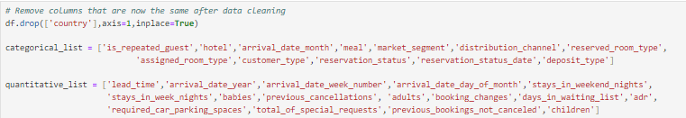
Next, bivariate visualizations are generated to identify potential relationships between the independent variables listed in the above screenshot, and the chosen dependent variable (“is_canceled”).
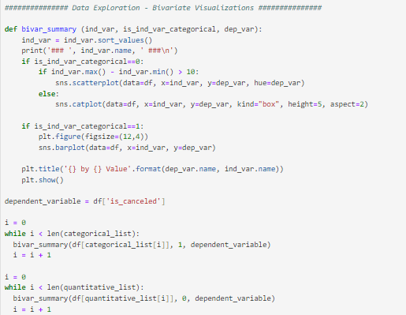
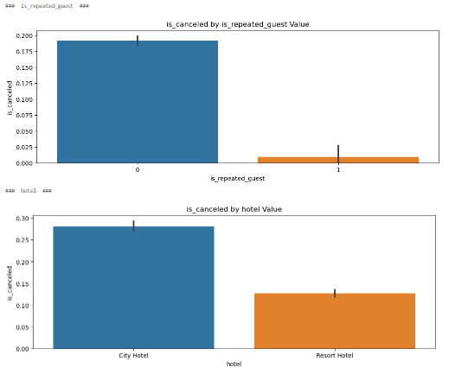
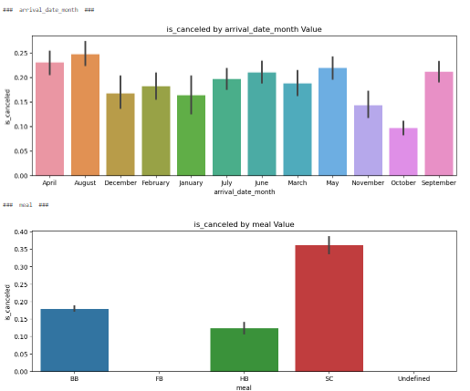
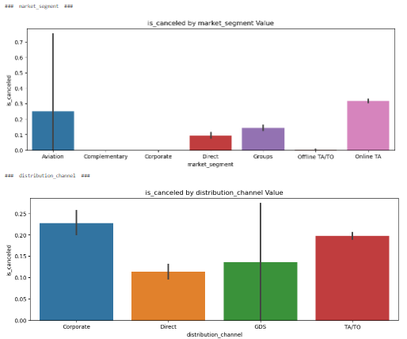
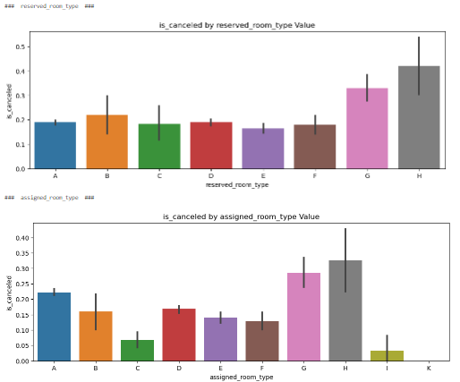
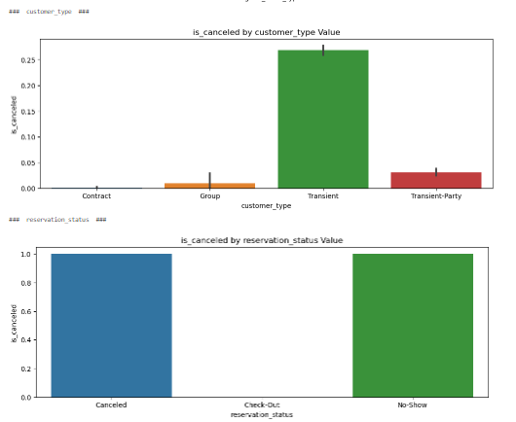
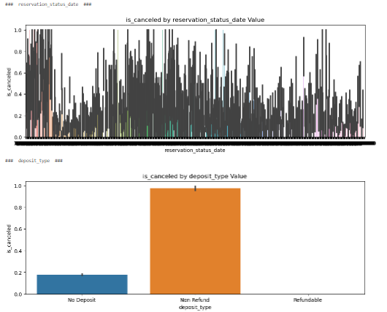
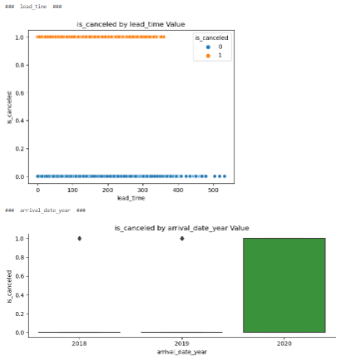
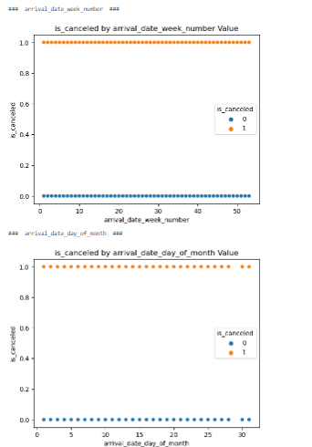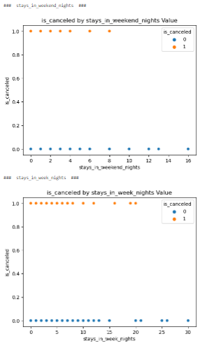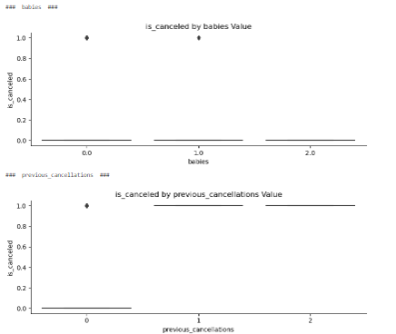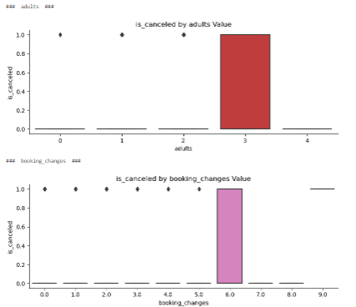
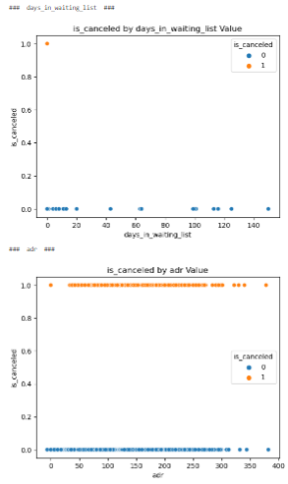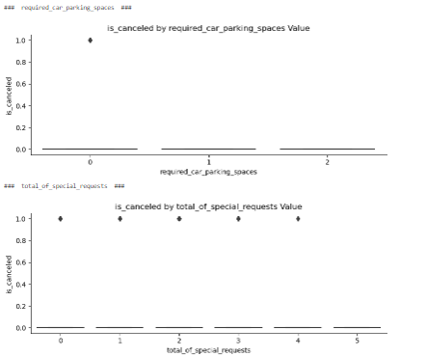
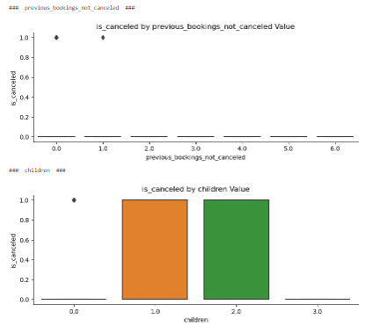
One of the outcomes of bivariate visualization is the clear correlation between the “reservation_status” field and the dependent variable. Since a value of “No Show” in “reservation_status” still means that the reservation was not completed, if those are handled as cancellations then “reservation_status” has a 1:1 correlation to “is_canceled.” As the use of highly correlated independent variables is a potential pitfall for regression analysis, the “reservation_status” field is therefore removed (Ranganathan et al, 2017). Prior to removal, it is first used to ensure that all “No Show” records reflect an “is_canceled” value of 1 (indicating the reservation was cancelled).
To prepare the data for modeling, otherwise extraneous columns are removed from the dataframe, such as those that were created to identify outliers. The resulting cleanup is then verified by printing the structure of the dataframe to confirm the appropriate columns are listed. This represents the prepared and cleaned dataset.
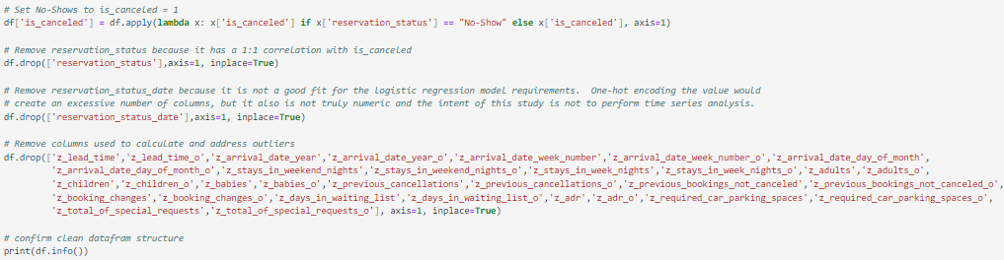
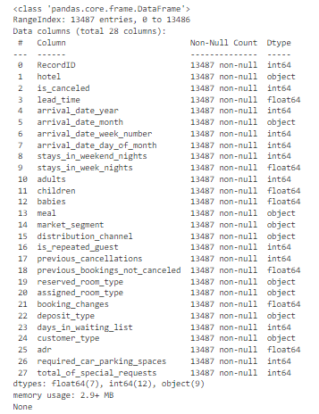

D – Analysis
The prepared data is used to create a Logistic Regression model. Logistic Regression is suited to classification projects, such as whether a loan will be approved, the likelihood of a particular clinical diagnosis, or in this case whether a hotel reservation is likely to be cancelled. The goal is to create a model that performs with accuracy greater than 60% with as few variables as possible so that the model is also simple and easy to describe. To identify which variables are candidates for the model, statistical evaluations are applied to each independent variable’s correlation to the dependent variable. This will provide more precise results than those achieved by visualization alone.
To evaluate independent variables for the initial model, ANOVA was applied to the quantitative variables and a Chi Squared test was applied to the categorical variables. Independent variables that produced a p-value less than an alpha of 0.05 were identified for inclusion in the initial model. This leads to a result suggesting that nearly every variable should be included in the initial model. Many of these variables have been identified as predictors in previous studies. A similar study used Logistic Regression rather than Banza’s approach of a CatBoost model and detected correlations between cancelled reservations and the following factors: adults, is repeated guest, previous cancellations, previous bookings not cancelled, booking changes, days in waiting list, required car parking spaces, and total of special requests (Almotiri et al, 2021).
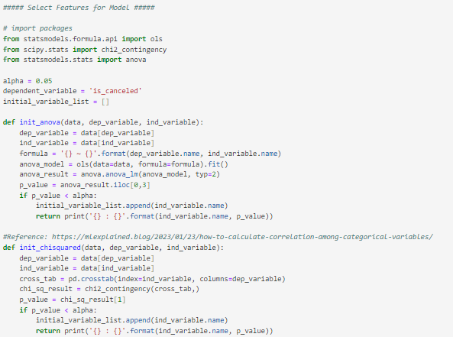
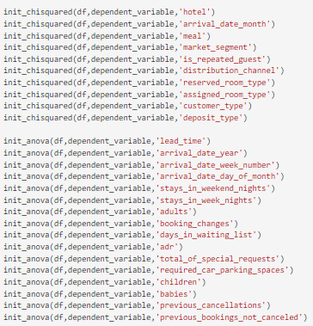
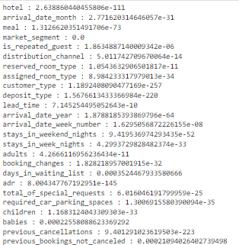
Since the variables identified for the initial model do include categorical columns, each value was separated into distinct columns to prepare those variables for the model.
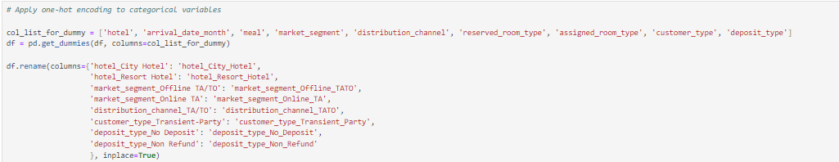
This list, however, is rather long and would benefit from feature reduction since it would be helpful for the business user to have the simplest possible model with which to work when adjusting booking strategies. To achieve feature reduction, the now-encoded variables are passed to a pipeline that will evaluate them for importance compared to the dependent variable. This pipeline leverages a Recursive Feature Elimination with Cross-Validation (RFECV) technique, estimating based on a Decision Tree Classifier, to evaluate the Logistic Regression outputs. This evaluation is performed against data that has been split into five folds. This means 20% of the data is used for validation while the remaining 80% is used for training, and then another 20% is used for validation, repeating until each fold has been used as a validation set and a score obtained for each of those model runs. The mean of these scores is then used as the outcome. The results from the output scores are compared with a decision tree until the features are evaluated and the most important features identified. The metric used for comparison in this study is accuracy, so accuracy is the score that is output at this step.
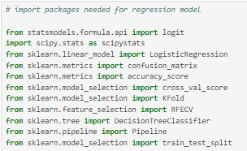
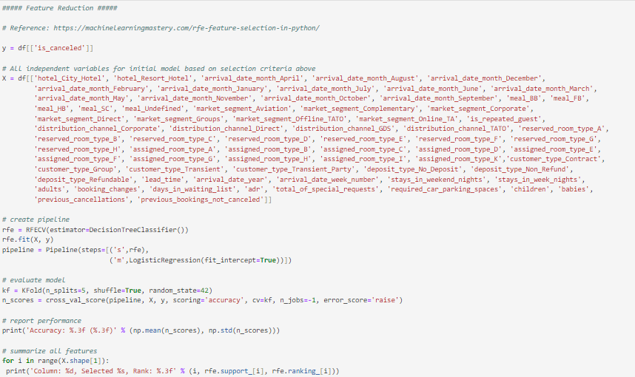
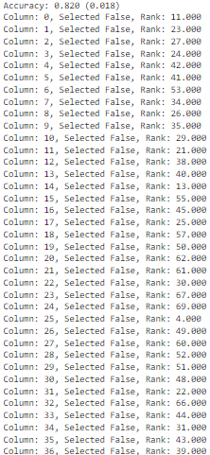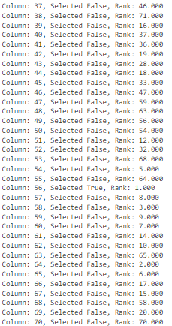

The column identified during the feature selection process above as the most important predictor is column 56, which is lead time in the dataset. An 82% accuracy rate is anticipated with lead time as the predicting variable. Therefore, we can prepare a Logistic Regression model with a predictor of “lead_time” against our dependent variable of “is_canceled.” Before creating and fitting this model, the data is split into test and train sets, with 30% of the data being used for testing and 70% of the data being used for training. A random_state value is assigned to support repeatability.
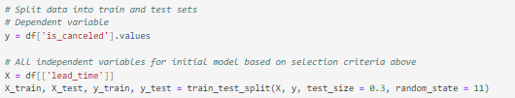
The Logistic Regression model is fit to the training data and the test set is used to make predictions. A confusion matrix is then generated comparing the results from the training data and the test data. An accuracy score is printed as well as a classification report. These evaluation tools indicate an accuracy score of 80%. In the test data, the outcomes from the model were as follows: 3,247 true positives, 800 false negatives, 0 false positives, and 0 true negatives. Interestingly, the model does not predict completed reservations in this case, but only cancelled ones, and does so with 80% accuracy.
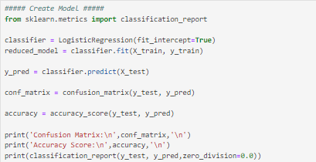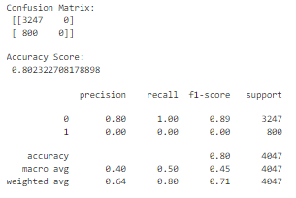
The Logistic Regression model can also be created via a different python package, statsmodels, which produces more detail in its summary reports. The outcome is similar, an approximately 81% accuracy. 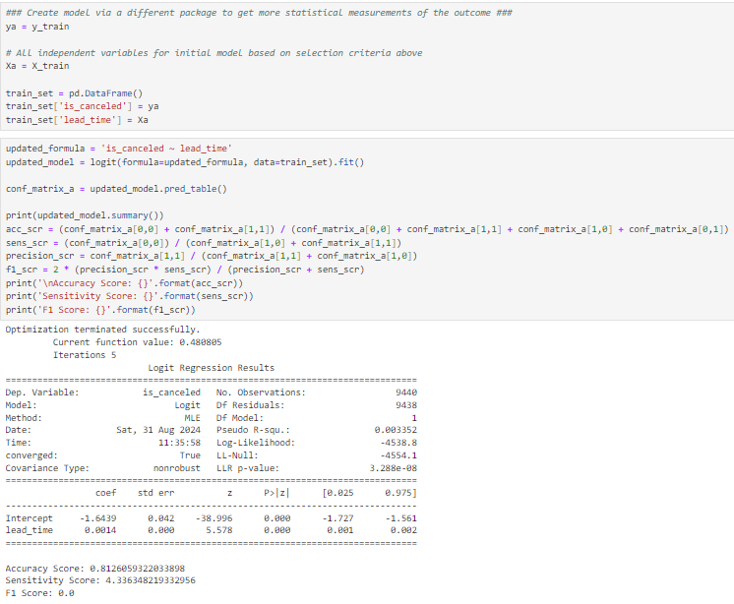The model indicates that for each day lead_time increases, the log odds of a cancellation increase by 0.0014. In other words, for each day of increase in lead_time, the likelihood of a cancellation increases by 0.14%. This is not a dramatic increase, but does accumulate, as can be visualized in the graph below showing a regression line steadily increasing, but without a drastic slope. With lead_time days of zero, the odds of a cancellation baseline at 31.2%. Once the lead_time value reaches 290 days, the odds of a cancellation reach 50%. This is based on the following formulas:
log(p/(1-p))(lead_time=290) = -1.6439 + (0.0014*290) = -1.2379
log(p/(1-p))(lead_time=0) = -1.6439 + (0.0014*0) = -1.6439
-1.2379 – (-1.6439) = 0.406
Exp(0.406) = 1.500 = 50% increase

Further model evaluation reveals additional observations about its performance. For example, in the test set, all cancellations are predicted to be zero (0), or not cancelled. This is also shown in the following visualization, where predictions are displayed in red. The overall probability that a reservation does cancel fits the regression line assigned to the original data set (original line in blue, predicted probability in green). The model anticipates that most reservations (around 80%) will not cancel. This is consistent with the actual results in the overall data set, where approximately 80% of reservations were completed.
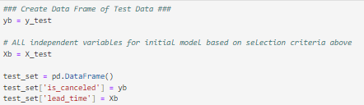
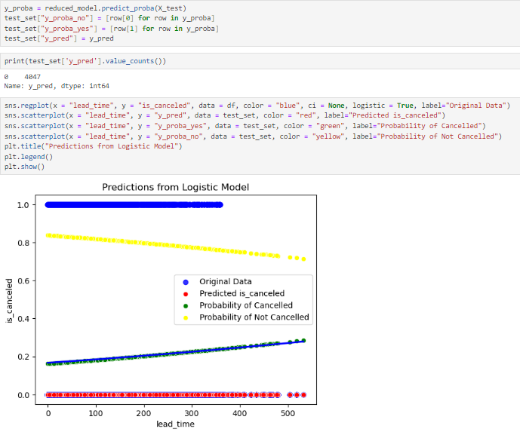
To evaluate the model further, an intercept-only model is created and the summary results printed. This provides a comparison point for whether the addition of the predictor variable made an impact on the model overall.
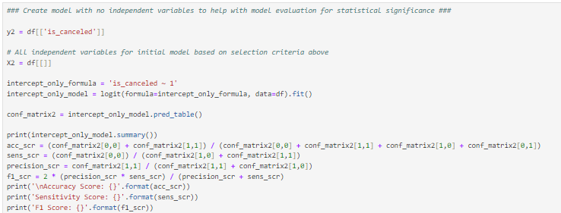
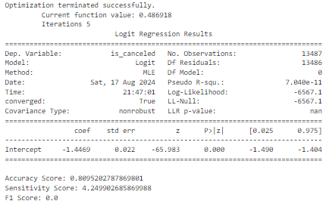
The Log-Likelihood of the “lead_time” model training data is -4,538.8. The Log-Likelihood of the intercept-only model is -6,567.1. The “lead_time” model is superior by this first comparison. The difference between these is (-4,538.8) - (-6,567.1) = 2,028.3. Multiplying that by 2 yields 4,056.6. The difference in degrees of freedom between the two models is 1. Applying these calculations to a Log Likelihood Ratio Test yields a p-value of 0.0, indicating that the difference is statistically significant and the addition of “lead_time” as a predictor made a meaningful difference to the model.
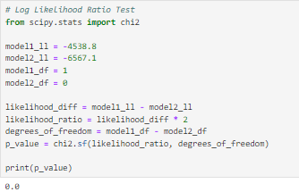
The two versions of the model can also be compared by their AIC scores, Akaike Information Criterion. The model using lead_time as a predictor has an AIC score of 9,081.6. The intercept-only model produces an AIC score of 13,136.1. A lower AIC score is an indication of better fit, so by this metric, the model predicting with lead_time is the preferred model.
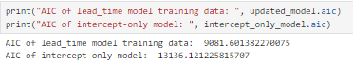
The final evaluation tool applied to the model is the AUC score and ROC Curve. These measures indicate how much better than random chance a Logistic Regression model performs. By this evaluation, the model may not be drastically better than chance, with an AUC of 0.56. While this score is better than the 0.5 of random chance, it is not significantly higher and so does have room for improvement.
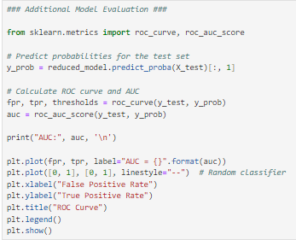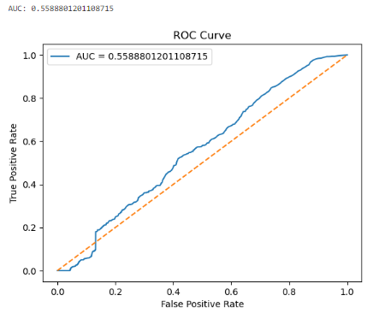

Overall, it would appear the Logistic Regression model has performed well, has achieved the goal of the study, and has confirmed the hypothesis that a Logistic Regression model can be constructed on the data and used to predict cancellations with greater than 60% accuracy. The simplicity of the model is advantageous, making it straightforward to explain to a business user and the results straightforward to interpret – as the lead time of a reservation increases, there is an increase to the likelihood that the reservation will result in a cancellation or no-show. The simplicity of the model can also be thought of as a disadvantage, however, as it does not account for additional nuance in the way that other techniques, like decision trees and neural networks, would facilitate.

E – Data Summary and Implications
The study confirms that reservations with a longer lead time can be used in a Logistic Regression model to reliably predict whether a cancellation is likely for a hotel reservation. This means that hoteliers could monetize this predictability by intentionally overbooking a percentage of their rooms based on how far in advance online reservations are made. Based on these results, a reasonable recommendation would be for business leaders to leverage their domain knowledge in addition to this predictive tool to decide how high an overbooking percentage is reasonable for their specific hotel given other factors not measured in this analysis. External factors and information could be paired with this analysis on lead times to maximize the occupancy rate of the hotel.
The study is limited by the number of years of data available. Three years, particularly when the timeframe is also impacted by the COVID-19 pandemic, is not a long time to measure and so having more data without the external pressures of disease might have led to different results. It is possible that the lead times in this study were more likely to have led to cancellations because of the restrictions the world faced while navigating COVID-19 lockdowns.
For future study, application of a neural network model may provide a more nuanced conclusion than the simpler results achieved here. An alternative approach could also be taken to remove the “is_canceled” column as the dependent variable and instead study the “reservation_status” column, which would add the additional nuance of no-shows versus cancellations. It may be that lead_time is a more refined predictor when there are more than only binary outcomes predicted.

F – References
Almotiri, S., Alosaimi, N., Abdullah, B. (2021). Using API with Logistic Regression Model to Predict Hotel Reservation Cancellation by Detecting Cancellation Factors. International Journal of Advanced Computer Science and Applications, 12(6). Retrieved August 7, 2024 from https://thesai.org/Downloads/Volume12No6/Paper_88-Using_API_with_Logistic_Regression_Model.pdf

Banza, Manuel. 2020. Predict Hotel Cancellations. Hospitalitynet. Retrieved August 4, 2024 from https://www.hospitalitynet.org/opinion/4099297.html

BasuMallick, Chiradeep. (2022). R vs. Python: 12 Key Comparisons. Spiceworks. Retrieved August 7, 2024 from https://www.spiceworks.com/tech/devops/articles/r-vs-python/

Bobbitt, Zach. 2020. The 6 Assumptions of Logistic Regression (With Examples). Statology. Retrieved August 4, 2024 from https://www.statology.org/assumptions-of-logistic-regression/

GeeksForGeeks. (2023). SAS vs R vs Python. Retrieved August 4, 2024 from https://www.geeksforgeeks.org/sas-vs-r-vs-python/

IBM. (n.d.). What is Logistic Regression. IBM. Retrieved August 4, 2024 from https://www.ibm.com/topics/logistic-regression

Krishnadas, Govind. 2022. Hotel Revenue. Kaggle.com. Retrieved August 4, 2024 from https://www.kaggle.com/datasets/govindkrishnadas/hotel-revenue

Ranganathan P, Pramesh CS, Aggarwal R. Common pitfalls in statistical analysis: Logistic regression. Perspect Clin Res. 2017 Jul-Sep;8(3):148-151. doi: 10.4103/picr.PICR_87_17. PMID: 28828311; PMCID: PMC5543767.

